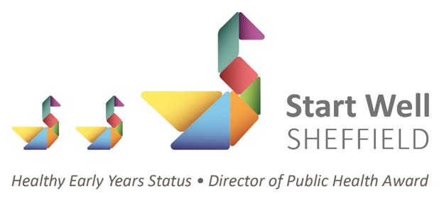
The Healthy Early Years Award (HEY)
This is a quality assurance award*, accredited by the Director of Public Health. The training and award recognises and celebrates a whole setting holistic approach to healthy early years. The award covers seven key strands and promotes and supports key Public Health messages, demonstrating a commitment to supporting children, families, staff and the wider community in making informed choices supporting both physical, mental and emotional health and wellbeing. Achieving the award demonstrates a commitment to ongoing reflective practice, aligning with Ofsted and Department for Education expectations, and supporting continuous improvement within provision.

The 7 key strands covered are:
- Food & Healthy Eating
- Leadership & Management
- Health & Safety
- EYFS Prime Areas
- Parent Partnership & Involvement
- Building Relationships & Supporting Infant Feeding
- Immunisations

To undertake the award, settings are required to:
- Attend all training sessions
- Work together as a whole team to complete a reflective toolkit
- Complete and submit the toolkit, an action plan and a Healthy Early Years communication plan

*The HEY Award is suitable for providers where practice has been positively recognised by Ofsted or following discussions with the LA Quality Team Managers.
For more information, please see Sheffield City Council Early Years Professional Development Training page or email EarlyYearsBusinessSupport@sheffield.gov.uk
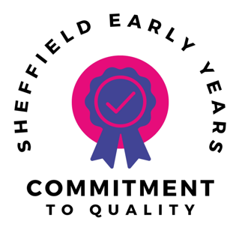

Commitment to Quality Award
The Commitment to Quality (C2Q) Award is Sheffield's Early Years quality recognition programme, celebrating settings that demonstrate excellence beyond statutory requirements. Through a supportive application, assessment and sharing process, the award recognises high-quality practice, promotes professional reflection and provides opportunities for schools and settings to showcase their unique areas of expertise. Successful settings become part of a city-wide network committed to improving outcomes for children, sharing effective practice and supporting continuous improvement across the Early Years sector.
If you are a Sheffield school or early years provider, are you proud of an aspect of your Early Years provision that goes above and beyond statutory expectations? The Commitment to Quality (C2Q) Award offers an opportunity to gain recognition for high-quality practice, reflect on your strengths and share your expertise with colleagues across Sheffield. Through a supportive process involving professional dialogue, learning walks and celebration of effective practice, C2Q helps build a strong network of settings committed to delivering the very best outcomes for children.
For more information about the application process and how you and your setting could achieve this award, please email EarlyYearsBusinessSupport@sheffield.gov.uk

