By Chloe Wright (occupational therapist), Laura McQuillin (occupational therapist)
& Faye Simpson (therapy assistant practitioner)
Sheffield Children’s NHS Foundation Trust
January 2022
CLOSING THE GAP WITH COOPERATIVE WORKING AND ASSISTIVE TECHNOLOGY:
MENU OF TECHNOLOGY
Table of contents

Page 1………Table of contents

Page 2………Table of contents

Page 3………. Low Tech
- Desk set up
- Sloping Board
- Foot box
- Height adjustable table
- Dycem matting
Page 4………. Low Tech continued
- Supportive back cushion
- Postural wedge cushion
- Posture pack
- Laptop/table raiser or angled rest
Page 5………. Low Tech continued
2. Small equipment
- Pencil gripper
- Alternative pens/pencils - (ergonomic, weighted, fat, skinny, triangular, coloured/gel pens)
- Paper - (coloured, graph, spacing, textures, personal workbook, post it notes)
- Coloured overlays
Page 6………. Low Tech continued
3. Position in the Classroom
4. Sensory equipment
- Ear defender
- Privacy board
- Fidget toys
Page 7………. Low Tech continued
- Sensory breaks
- Visual schedules
- Timers
- Leave early/Time-out pass
Page 8………. Low Tech continued
- Chew aid e.g. ‘Chewellery’, pencil toppers etc
- Weighted items e.g. lap-pads, shoulder comforters, weighted toys
- ‘Movin-Sit Cushion’
5. Other
Page 9………. High Tech
1. Laptop/Computer/Tablet/iPad
2. Programmes
2.1 Word-processing software
- Clicker 8
Page 10………. High Tech continued
- Docs Plus
Page 11………. High Tech continued
2.2 Mind mapping software
- Inspiration V9 Mind Mapping
- Mind View 5 AT
Page 12………. High Tech continued
- Jamboard
2.3 Typing Programmes
- Nessy Fingers
Page 13………. High Tech continued
- English Type Junior and Senior
- Free online typing games
Page 14………. High Tech continued
- Free online typing games continued
Page 15………. High Tech continued
3. Speech to text (dictation)
3.1 Inbuilt dictation for computer/tablet/iPad
3.2 Dragon Dictate Software
Page 16………. High Tech continued
4. Scanning Pens

Low Tech
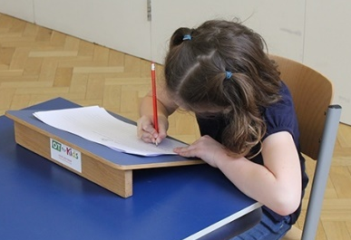
- Desk set up
Sloping board
Helps to stabilise wrist and forearm during writing activities.
Benefits:
- Improves postural stability and upper limb position for children that present with increased flexibility in joints
- Reduces the impact of fatigue when writing

Foot box
Provides a stable base of support for feet.
Benefits:
- Children that are unable to reach the floor
- Improves postural stability and writing position at the desk
- Provides grounding sensory feedback

Height adjustable table
Might be considered for children that can’t reach the table or children who prefer to stand when writing.
Benefits:
- Provides an alternate change of position and dynamic working space
- Allows for additional movement when working to aid regulation and provide sensory input
- Improved posture when writing

Dycem matting
Non-slip surface that helps to keep objects in position.
Benefits:
- Keep workbooks in place and prevents them from slipping. Useful for children who don’t stabilise their paper / text-book with their non-dominant hand
- Very discreet

Supportive back cushion
Improve postural position. Can provide lumbar support for children that are naturally low toned and struggle to maintain upright posture. Useful when the seat depth is too large for the child.
Benefits:
- Improve posture when writing/typing
- Reduce impact of postural fatigue
- Improved comfort for seated activities

Postural wedge cushion
Facilitates anterior pelvic tilt to create a more functional posture for seated tasks.
Benefits:
- Improve posture when writing/typing
- Reduce postural discomfort
- Reduce postural fatigue

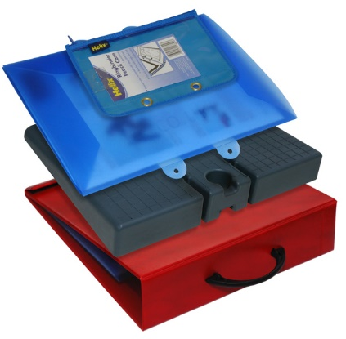
Posture pack
Contains writing slope with pencil/paper storage, carry handle and postural wedge cushion.
Benefits:
- Could also be used with laptops/tablet
- Support postural stability at desk
- Portable and compact
- Combined angled writing slope and postural wedge cushion

Laptop/tablet raiser or angled rest
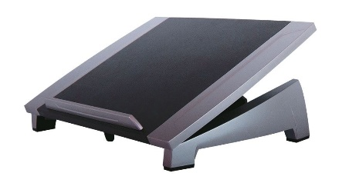
Brings the laptop screen to eye level, thus bringing body into upright posture.
Benefits:
- Improved posture and reduce effects of neck and back discomfort
- Can be used with height adjustable table
- Can improve upper-limb positioning for keyboarding

- Small equipment
Pencil gripper
Placed on a pen/pencil to improve hand position and grip when writing, or to aid comfort.
Benefits:
- Reduce the impact of pain, discomfort and fatigue when writing
- Encourage more functional or dynamic pen/pencil position
- Potential to improve the quality and fluency of writing through development of a more functional grip

Alternative pens/pencils - (ergonomic, weighted, fat, skinny, triangular, coloured/gel pens)
Variety of different options depending on the individual needs of the child. May support better grip position or promote improved fluency.
Benefits:
- Increased engagement in writing tasks
- Autonomy over own work when they are involved in selection process of choosing a pen/pencil
- Reduced pain and discomfort when writing

Paper - (coloured, graph, spacing, textures, personal workbook, post it notes)
Utilising different types of paper for writing tasks.
Benefits:
- Greater engagement and improved motivation
- Coloured paper may help children with specific learning difficulties, dyslexia, visual perceptual problems or sensory processing difficulties
- Paper that provides visual cues on how to physically organise work on the page is useful for children with poor praxis and coordination
Coloured overlays
Sheets of translucent or transparent coloured plastic that can be placed over a page to colour the text underneath.
Benefits:
- Reduce the impacts of visual difficulties when reading
- Can be used over books and laptops/tablets
- Reduces visual contrast for children with sensory processing difficulties and can also assist reading for those with specific learning difficulties (as with coloured paper)

- Position in the Classroom
Consider the child’s needs in relation to factors such as sensory processing, attentional abilities, anxiety etc. Would the child benefit from any of the following:
  - Reduce auditory distractions (e.g. not seated near the doorway, other busy areas or near other children who are known to make increased noises in class)
  - Reduce visual distractions (e.g. front of class and able to see the board without having to look around other children or obstacles)
  - Not in thoroughfare/aisles to minimise sensory distractions from others in the class
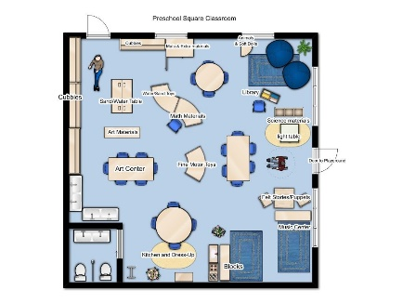
  - Separate desk space
  - Work buddy (e.g. being seated with a student who may have a positive influence on the child’s output)
  - Option to work out of class if required (e.g. when learning to use AT)
  - Clear exit route and/identified safe-space to reduce anxiety

- Sensory equipment
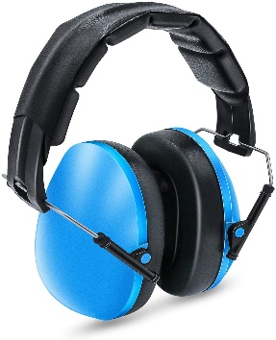
Ear defenders
Used to block out/reduce loud noise - (N.B. Must not be used for prolonged periods of time).
Benefits:
- Useful for children who struggle to filter auditory information
- Useful for anxious children who may struggle with increased sensory sensitivities
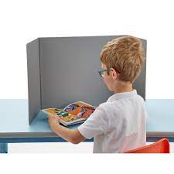
Privacy board
A sheet of foldable plastic that can be placed on the desk to provide a private workspace.
Benefits:
- Limit distractions and sensory information (visual, auditory)
- Increase focus
- Provides a calm space
Fidget toys
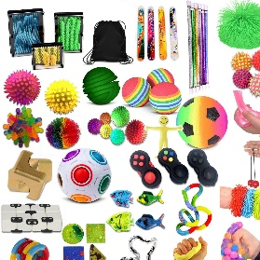
Small equipment that can be used to help children self-regulate throughout the day.
Benefits:
- Increase attention, focus and active listening
- Promote sensory regulation
- Reduce the impact of anxiety
Sensory breaks
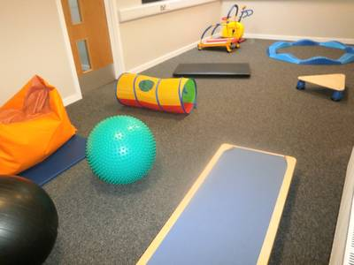
Times in the day that provide the child with an opportunity to ‘re-set’ themselves through a sensory-based activity e.g. deep proprioceptive or physical activity; Sensory Circuits etc.
Benefits:
- Improved focus, concentration and attention
- Improved regulation throughout the day
- Reduce the impact of anxiety
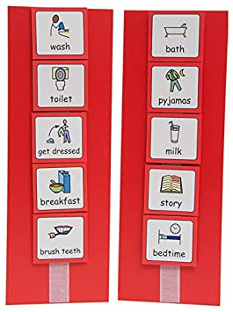
Visual schedules
Pictures or symbols that are used to clearly describe expectations of an activity or events in the day.
Benefits:
- Useful for children who may struggle to process or understand verbal instructions
- The child can refer back to it in their own time, thus increasing autonomy and providing reassurance.
- Reduces stress and anxiety about what to expect
- Helps children to embark on tasks or activities

Timers
Used to measure time and provides a clear visual indicator to the end of an activity.
Benefits:
- Acts as a visual prompt to engage in a task
- Motivational tool to finish an activity in a set time frame
- Reduces anxiety regarding a task by providing a clear endpoint

Leave early/Time-out pass
A card or slip of paper that provides child with opportunity to leave classroom when required e.g. when over-whelmed or needing a break.
Benefits:
- Develops self-awareness of when they require a break
- Increase autonomy and independence
- Reduces anxiety by providing control and a clear ‘exit’, which can help children to stay on task for longer
Chew aid e.g. ‘Chewellery’, pencil toppers etc
A piece of sensory equipment that provides oral input.
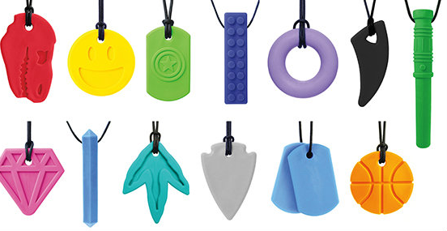
Benefits:
- Provides increased proprioceptive feedback
- Known to be calming and regulating
- Help a child to self-regulate autonomously
- Improves focus and attention
- Reduces anxiety
Weighted items e.g. lap-pads, shoulder comforters, weighted toys
Provides a form of deep pressure to help with sensory regulation.
Benefits:
- Regulates sensory system
- Increased proprioceptive input can increase a child’s ability to tolerate activities, (e.g. seated tasks)
- Comforting and reduces anxiety
‘Movin-Sit Cushion’
An air-filled wedge-shaped cushion that encourages an active sitting posture and provides proprioceptive input whilst seated.
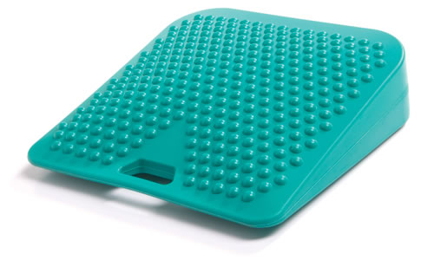
Benefits:
- Helps children that need movement or can be fidgety
- Increased engagement in classroom activities
- Can be used on most classroom seats or during floor activities
- Assists regulation throughout the day
- Facilitates anterior pelvic tilt to create improved posture for seated activities

- Other
Consider the child’s needs in relation to their recording abilities and their developmental profile or any known diagnoses. Would the child benefit from any of the following:
- Scribe
- Pre-prepared lesson handouts
- Writing down verbal instructions for tasks (for the child to have with them on the desk)
- Picture prompts for tasks
- Work planning sheets e.g. spider diagram, comprehension sheets, matching answers
- Alternative methods of communicating learning e.g. PowerPoints, oral presentations, posters etc.
- Teaching Assistant support for specific components of the task, e.g. initiation, planning, checking-in ideas, spelling etc.
High Tech
- Laptop/Computer/Tablet/iPad
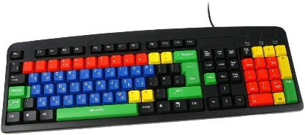
- With/without detachable keyboard
- With/without detachable mouse
- Larger keys keyboard
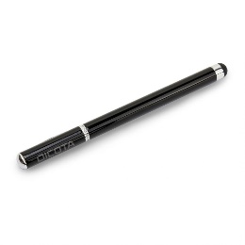
- Coloured keys or keyboard
- Coloured/high contrast overlays for keyboard
- Ergonomic keyboard
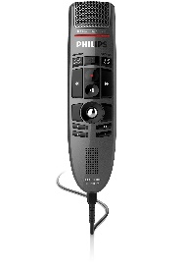
- Keyguards/hiding unnecessary keys
- Lower case keyboard
- Large mouse/ergonomic mouse
- Stylus for tablets/iPads (with/without mount)
- Joystick
- Switches
- Microphone
- Headphones
Things to consider:
- Childs fine motor and upper-limb function
- Visual processing/discrimination
- Learning level/capacity
- Concentration and focus
- Sensory processing preferences
- Communication abilities – both receptive and expressive communication
- Long-term aims and aspirations

- Programmes
2.1 Word-processing software
Clicker 8
A word-processing programme that is useful for literacy-based tasks. There are many inbuilt functions such as speech feedback, talking spell checker and word predictor functions. There are also mind-mapping features, sentence support, word banks and symbols to support developing writers. Can be downloaded for Windows, Mac, Chrome and IPad.
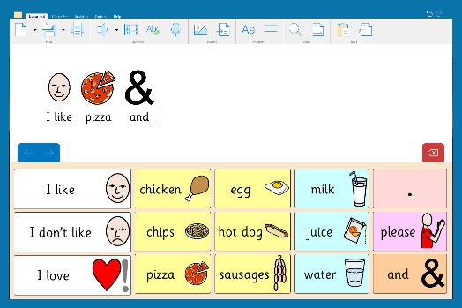
Benefits:
- Supports learners with reading and writing difficulties
- In-built mind mapping
- Word banks and predictions
- Spell check
- Easier layout than Microsoft programmes
- Can be used as an alternative to a scribe for assessments and exams giving students greater autonomy
- Text to speech read back
Things to consider:
- Time to set up the programme to the student’s preferences
- Staff teaching
- Pupil teaching and learning level
- I.T. support for any trouble shooting
Who would benefit:
- Children that have reading and spelling difficulties
- Children that struggle to formulate sentences
- Children that benefit from combined symbols and texts
- Children that would benefit from hearing back their work
- Children that become distracted by additional features on Microsoft programmes or who would benefit from a simpler layout
- Children who struggle with initiating and planning their work
https://www.cricksoft.com/uk/clicker/8/word-processor
Docs Plus
Similar programme to Clicker 8 but targeted at young adults and higher education. Has many of the same features as Clicker 8. Can be downloaded for Windows, Mac, Chrome and IPad.
Benefits:
- Supports learners with reading and writing difficulties
- In-built mind mapping
- Word banks and predictions
- Spell check features
- Easier layout than Microsoft programmes
- Can be used as an alternative to a scribe for assessments and exams giving students greater autonomy
- Text to speech read back
Things to consider:
- Time to set up the programme to the student’s preferences
- Staff teaching
- Pupil teaching and learning level
- I.T. support for any trouble shooting
Who would benefit:
- Students that have reading and spelling difficulties
- Students that struggle to formulate sentences
- Students that benefit from combined symbols and texts
- Students that would benefit from auditory feedback
- Students that become distracted by additional features on Microsoft programmes or who would benefit from a simpler layout
- Students who struggle with initiating and planning their work
https://www.cricksoft.com/uk/docsplus/win-mac
2.2 Mind mapping software
Inspiration V9 Mind Mapping
“Brainstorm ideas, structure your thoughts and visually communicate concepts to strengthen understanding with the Diagram and Map Views. To take notes, organise information, and structure writing for plans, essays, and reports, use the integrated Outline View. With Inspiration's Presentation Manager, transform your diagrams, mind maps and outlines into polished presentations that communicate ideas clearly and demonstrate understanding and knowledge.”
http://www.inclusive.co.uk/inspiration-v9-p2227
Mind View 5 AT
“MindView AT has been designed to help visual thinkers create impressive written assignments and presentations. The smooth transition from a Mind-Map to Word and PowerPoint means students can make powerful, formatted documents ready for assessment. The added assistive technology software functionality, including text-to-speech, Dragon integration, predictive text, and audio notes make MindView AT the industry leader in mind mapping for assistive purposes.”
http://www.inclusive.co.uk/mindview
Benefit of Mind Mapping Software:
- Reduces typing demands – short words and phrases
- Helps to visualise ideas
- Fun way of learning and documenting ideas
- Motivating
- Useful note taking tool
Things to consider:
- Set up and I.T. troubleshooting
- Cost
- Might be difficult for students to further elaborate on points
- Staff teaching
- Pupil teaching and learning level
Who would benefit:
- Individuals who benefit from visual feedback
- Children that struggle with concentration and focus
- Student’s that struggle to plan their work and formulate sentences
- For children where writing/typing fatigue may be an issue
Jamboard
A collaborative white board, which can also be used to plan and share ideas. Can be used individually or for group activities.
Benefits:
- Can be used to make notes, mind map etc.
- Free if you have a Google email address
- Simple and easy to use
- Can be shared with other students and teachers
Things to consider:
- Requires a Google email address to access
- Internet connection required
Who would benefit:
- Individuals that benefit from visual feedback
- Children that struggle with concentration and focus
- Children where writing/typing fatigue may be an issue
- Learners who may benefit from collaborative working
https://jamboard.google.com
2.3 Typing Programmes
Nessy Fingers
“Nessy gets children typing real words fast and introduces spelling practice immediately.
Keys are introduced alphabetically which makes sense to children. This is different to most other typing programs, which mix up random letters. Nessy Fingers is suitable for ages 7+.
The program has been designed to be used by both beginners who have never typed before, or those with keyboard experience, who want to improve their typing speed. It is especially effective for children with dysgraphia, dyslexia and ADHD. Nessy Fingers follows a structured sequence of word lists that progress from easy to complex. Children can add their own words from school to practice spelling.”

Benefits:
- Simple and easy to use
- Multiple accounts can be set up on the one subscription so can be used with multiple students
- Fun and engaging
- Can be tailored to needs of child
Things to consider:
- Focuses on touch-typing, which is a challenging typing style not used by many competent typists
- Good concentration and attention required
- Learning capacity of the child
- Adult support
- Targeted at younger students – might not be appropriate for secondary school age
- Cost of subscription
- Can be difficult for children who struggle with a competitive element
Who would benefit:
- Children that have the capacity to learn and develop touch typing
https://www.nessy.com/en-gb/product/nessy-fingers-home
English Type Junior and Senior
“Englishtype Junior and Senior is the educational and fun way to teach touch typing for kids. Developed by an experienced Educational Psychologist especially for the UK Curriculum and designed by award winning game designers. Unlike other touch typing software, Englishtype maximises literacy benefits at the same time as teaching typing. Unique colour coding of fingers & letters boosts skill learning. Carefully selected age relevant & useful vocabulary (choose from 4 levels) is great for any ability level – challenging the brightest and including support for Special Needs.”
Benefits:
- Targeted at both primary and secondary school aged children, a more versatile programme
Things to consider:
- Focus on teaching touch-typing, which is a challenging typing style not used by many competent typists
- Good concentration and attention required
- Learning capacity of the child
- Cost of subscription
Who would benefit:
- Children that have the capacity to learn and develop touch typing skills
https://englishtype.com/special-needs/
Free online typing games
The below websites and software have not been fully trialled by the therapy team. It may be a case of trial and error to find the best suitable games and programmes for a child. If you would like anymore free typing games or lessons just type in ‘free typing games’ into your web search engine.
- www.typing.com
A free typing tutor that logs your progress. Typing lessons with minimal distraction and fun, animated typing games.
- www.sense-lang.org
Touch typing tutorials to guide you through locating and memorizing the letters and numbers on the keyboard and numeric keypad.
- edu.gcfglobal.org/en/typing/typing/1/
Clear instructions and guidance for practising typing skills and key location.
- www.freetypinggame.net
Play free typing games, typing lessons and typing tests online.
- www.powertyping.com
Free typing tutor online with typing lessons and games.
- www.learninggamesforkids.com/keyboarding_games.html-
Online learning games.
- www.bigbrownbear.co.uk/learntotype
Free typing games and lessons.
- www.dancemattypingguide.com
Free online program. For ages 7-11. No games, a reward for completing a section is a song and dance.
Benefits:
- Free (with internet connection)
- Easy to access
- Variety of different games to keep children interested and motivated
- Focus on key location and increasing typing speed
- Accessible for novice students, as well as providing practice for students who may already have a degree of keyboard familiarity
Things to consider:
- Internet connection required
- Age-appropriateness of programmes and games
- Need to be able to understand letters and symbols of keyboard
Who would benefit:
- Children that may struggle with structured typing lessons (e.g. learning to touch-type)
- Children who are looking to introduce typing as a method of recording their work
- Children who may benefit from building up enjoyment and confidence with typing

- Speech to text (dictation)
3.1 Inbuilt dictation for computer/tablet/iPad
Converts speech to text. Can be enabled through the accessibility settings of most laptops, computers, tablets and iPad.
Benefits:
- Plays to the strengths of individuals who are good verbal communicators
- Free - already built into most devices
- Accessible for students with broader literacy difficulties, e.g. struggle with spellings
- Requires minimal motor skills
Things to consider:
- Quiet environment with no background noise to be able to use effectively
- Still need to be able to type/use a computer to go back through work and edit
- Can mis-hear words
- Needs time and practise to get more proficient
- Require reasonable level of reading ability
- Need to be able to articulate words relatively clearly
Who would benefit:
- Students that are strong verbal communicators
- For students where fatigue is an issue
- Transferable skill if also using smart devices at home
- Students who have broader literacy difficulties, e.g. problems with spelling
- Students who may struggle to conceptualise ideas visually
- Students who have difficulties initiating recording via text, (i.e. writing or typing)
3.2 Dragon Dictate Software
A speech recognition programme that converts speech to text. “The Nuance Dragon Naturally Speaking 13 Premium is the full-feature edition of the speech recognition system and a simple way to interact with your PC - via your own voice. The premium version is intended for educational institutions and students.”
Benefits:
- Has additional functions that standard Microsoft dictation software doesn’t have, for example, inputting punctuation
- Greater independence, rather than relying on scribe
Things to consider:
- Cost
- I.T. troubleshooting
- Subscription limited to one device
- Need to have level of computer literacy and typing skills to be able to correct work as dictating
- Need to be able to articulate words relatively clearly
Who would benefit:
- Students that are strong verbal communicators
- For students where fatigue is an issue
- Students who have broader literacy difficulties
- Students who may struggle to conceptualise ideas visually
- Students who have difficulties initiating recording via text, (i.e. writing or typing)
www.UKTechStore.com £79.99 for a single user license (downloaded license)
- Scanning pens
“The reader pen or scanning pen is a portable, text-to-speech scanner. Pass the pen’s nib across a word and it instantly displays the definition while reading it aloud. It is a valuable notetaking and revision tool for students, teachers, and professionals.”
Benefits:
- Helps students to learn and understand new words as well as reading sentences aloud
- Portable and accessible
- Scan information directly to smart device or computer
- Can be used with headphones
- Eliminate the need for a reader during assessment and exams
Things to consider:
- Cost
- Needs practise for it to be most reliable
- Motor control and coordination to hold pen at certain angle
Who would benefit:
- Students that struggle with reading and recalling written information i.e. dyslexia
- Students that want to be more independent during tests and assessments
- SEND and EAL students
- Students with some visual difficulties

