Going Back to School
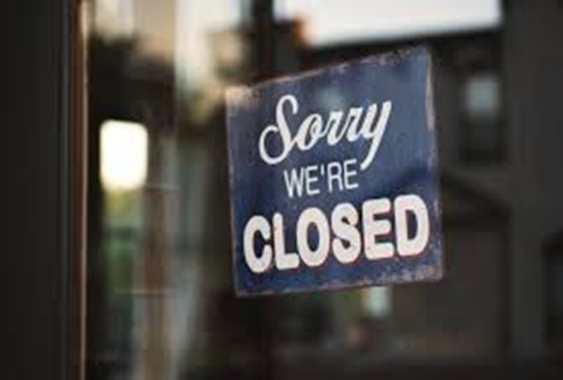
COVID-19 is a new virus that makes people unwell. COVID-19 is sometimes called coronavirus. Because it is new, lots of people have become ill with the virus. To help stop the virus from spreading, almost everyone has had to stay at home. Schools have been closed. Lots of other places have been closed too.

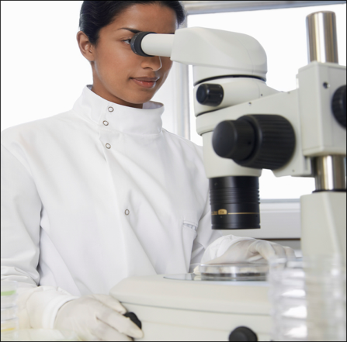
Scientists have been working hard to find out more about the coronavirus. Scientists have also been counting how many people have been getting ill with coronavirus. The number of people becoming ill with coronavirus is getting lower and lower. Scientists say it is now safe for some places to re-open. People in your family might be able to go back to work. Schools are also going to re-open. Some other places will also re-open too. Your family will know which places are open.

Because some people are still getting ill with the virus, it is important that we don’t get too close to other people when we are out of the house. Scientists say we must stay at least 2 metres away from people that we don’t live with. This is about the same length as a double bed. Scientists say that in some places people should also wear masks.
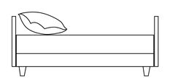
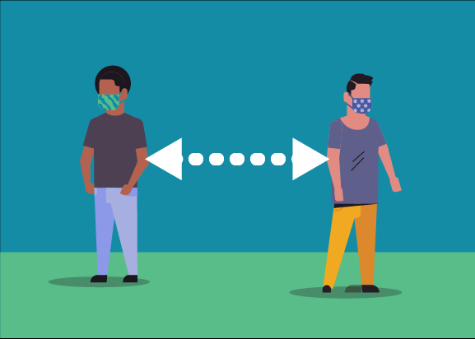
2 metres

This means that going back to school might be a bit different than before. This is to keep everyone safe and stop the virus from spreading. These are some of the things that might be different when I go back to school (edit as appropriate):
- I might only go to school on certain days
- There won’t be as many children in school
- There won’t be as many children in my class
- There won’t be as many children in the playground at break time.
- Lunchtime and break time might be a different times than before
- Children will be sat further away from each other in the classroom.
- My teacher and other adults might be wearing masks.

These are some of the things that will stay the same when I go back to school: (edit as appropriate)
- I will still go to the same school
- I will still have the same classroom
- I will still sit in the same seat
- I will still have the same teacher
- Break time will still be in the same playground
- I will still have computer time
- I can still use the quiet area if I need a break

Scientists say it is now safe for some children to go back to school. School might be a bit different when I go back but lots of things will stay the same.

