Going Back to School

Coronavirus is a new virus that makes people unwell. To help stop the virus from spreading, almost everyone has had to stay at home. Schools have been closed. Lots of other places have been closed too.
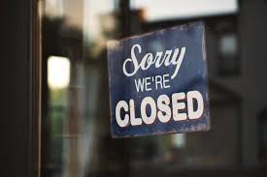

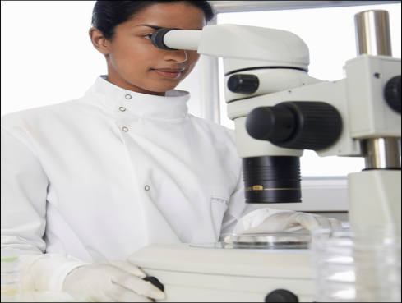
Scientists have been working hard to find out more about the coronavirus. Scientists say it is now safe for schools to re-open.

Going back to school might be a bit different than before. This is to keep everyone safe and stop the virus from spreading. These are some of the things that might be different when I go back to school: (edit as appropriate and include relevant pictures)
- I might only go to school on certain days
- There won’t be as many children in school
- There won’t be as many children in my class
- There won’t be as many children in the playground at break time.
- Lunchtime and break time might be a different times than before
- Children will be sat further away from each other in the classroom.
- My teacher and other adults might be wearing masks.

These are some of the things that will stay the same when I go back to school: (edit as appropriate and include relevant pictures)
- I will still go to the same school
- I will still have the same classroom
- I will still sit in the same seat
- I will still have the same teacher
- Break time will still be in the same playground
- I will still have computer time
- I can still use the quiet area if I need a break

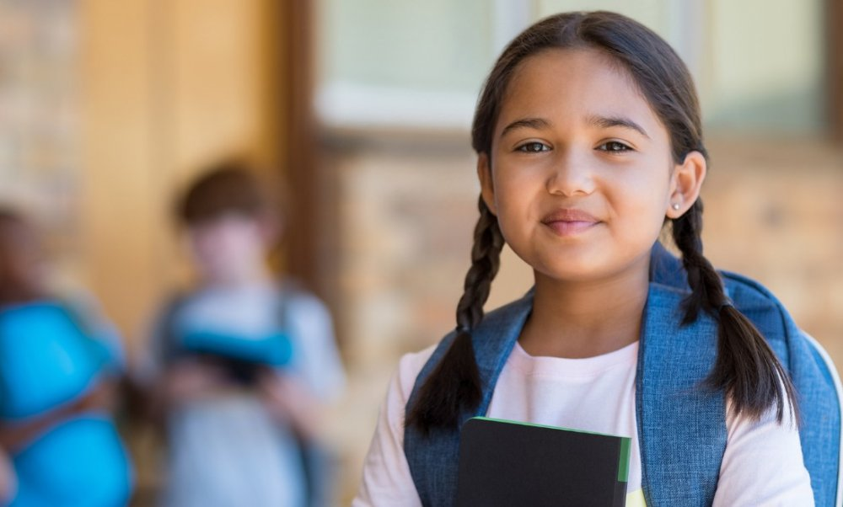
Scientists say it is now safe for some children to go back to school. School might be a bit different when I go back but lots of things will stay the same.

