PE At Home Resources

What’s up students and parents!

I hope everyone is staying safe out there and I will miss teaching you in PE class while we are not at school, but the good news is you already have all the skills, tools and knowledge you need to keep your body healthy.

I hope you can use all that we’ve learned in PE this year to stay active each day and if it’s safe and the weather is nice you could even try to get outside and play in your yards to keep yourselves active.

I’ve included some daily workouts for you to try out and also linked up a ton of resources and activities that you can check out if you get bored or need a fun activity to do.

If you want, you can have your parents tag me on Twitter or Instagram @thePEspecialist if you are working on any of these activities, I’d love to connect with you and see what you are up to.

Other than the daily workout and skill review options provided in this packet, you can find lots of additional ideas linked on the last page:

Optional Skills Review

If you have any of the equipment below (frisbee, ball, jump rope, balloon etc), you can practice reviewing or working on any of the skills that we’ve learned in PE class this year.

- Jump Rope: If you have a jump rope, you can review some of the Single Jump Rope Tricks we learned in PE, or if you have a sibling or family member you could even try out some of the Partner Tricks we learned
- Throwing and Catching: If you have space in your yard and it’s safe to go outside, try to practice throwing and catching with a family member with a ball or a frisbee
  - K-1: Underhand Throwing (ball)
  - 2-5: Overhand Throwing (ball)
  - How to throw a Frisbee
- Striking a Balloon (awesome activity for K-2nd Grade)
  - Blow up a balloon and practice striking it with different items in your house (or different body parts)
  - What is the hardest item or body part to control the balloon with? What’s your record for the most number of hits without moving your feet?
  - Here’s an example of this balloon striking activity
- Basketball: If you have a basketball or playground ball, practice some of the ball handling drills and challenges that we worked on in PE over the last few weeks
  - Ball Handling Drills Tutorial
  - Ball Handling Drills Follow Along

Stay Safe, Have Fun and Keep Yourself Active!

Coach Landers

DAILY WORKOUT

4K - Kinder - 2 times 3rd Grade - 5 times
1st Grade - 3 times 4th Grade - 6 times
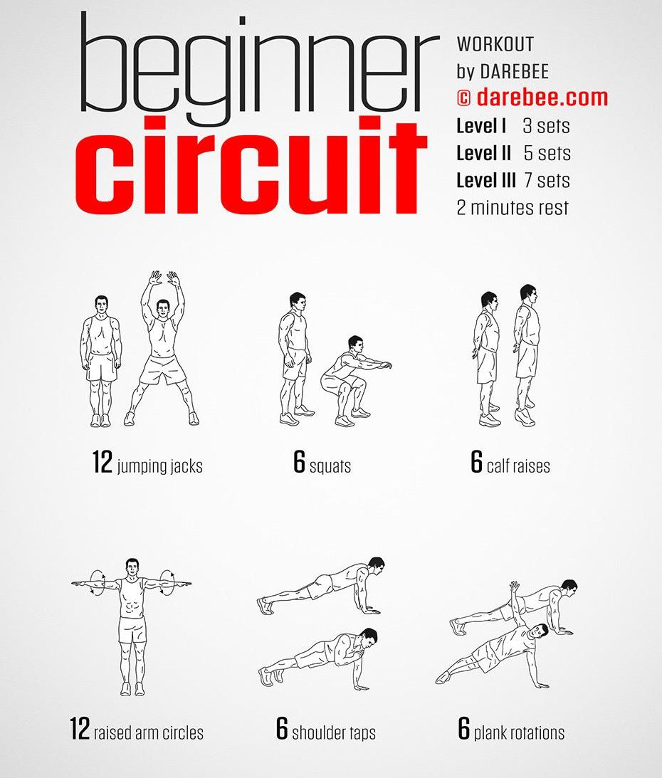
2nd Grade - 4 times 5th Grade - 7 times
Additional/Supplemental Online Resources and Activities for PE at Home

- Free Customizable Kid Workout Program
  - Sign up for Sworkit and use them for follow along workouts for kids
  - (they have a free kids workouts for anyone to use after signing up and they are even customizable and have student examples for all of the follow along workouts, just click on the “Kids Workouts” section after logging in)
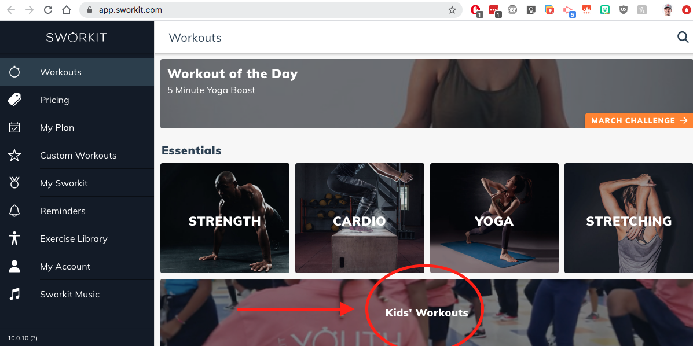
- Free One Page Paper Workouts from Darebee.com (Pick any of them here)
  - 4 minute warmup: https://darebee.com/workouts/4-minute-warmup-workout.html
  - Beginner Circuit: https://darebee.com/workouts/beginner-circuit-workout.html
  - Quick HIIT: https://darebee.com/workouts/quick-hiit-workout.html
- Online Follow Along Workouts
  - For example check out Fitnessblenders Youtube Channel
  - Another good one for Kids Workouts is Glenn Higgins Fitness
  - Do a Would you Rather Workout Video
- Follow Along Dances:
  - Pick your favorite Just Dance Video and bust a move
  - Have students complete GoNoodle Follow Along Dances
  - Happy Follow Along: https://youtu.be/_swUGtEpazY
- Practice or learn a popular Line Dance
  - Like the Cupid Shuffle for Example
  - Or the Sid Shuffle from the movie Ice Age
- Tons of at Home Activities and Resources
  - Active Home Resources from OPEN Phys Ed
- Activity Log:
  - Keep an activity log and track your activity over the break from school
    - Here are some examples of activity logs
- Activity Calendar (do 1 activity per day)
  - Here's some examples from SHAPE America
  - Here’s another example
- Home Activity Packets and from other PE teachers:
  - Pete Charrette: https://twitter.com/CapnPetesPE/status/1239202278122369031
  - Jenny Horowitz: Google Drive Folder
  - Kevin Tiller: https://twitter.com/physedreview/status/1239168726450286593
  - Bob Vogt: https://twitter.com/GlengaryPE/status/1239341018459377664
  - Jason Denk: https://twitter.com/mrdenkpeclass/status/1238508561447227393?s=11
  - CBHPE Activity Ideas: https://www.cbhpe.org/projector
  - PE Follow Along Videos Collection (Google Slide)
  - Create your own follow along dance or workout video for students to follow along to
No Internet?
Spectrum is offering 60 days of free internet to families who do not have access during the coronavirus pandemic: (info here) To enroll in the program, call 1-844-488-8395

