A Vision for Education in Sheffield:
A 5 Year Strategy 2018-2023

This document sets out a vision for the next phase of educational improvement in Sheffield.

It builds on the success of Learn Sheffield and the work that preceded it, capitalising on the key components of that success: a focus on school improvement, a belief in the value of sector-led partnership working & the necessity of a place specific strategic approach.

It recognises that, for the city to thrive and make the most of its human capital, it is essential that Sheffield’s education system delivers nationally leading outcomes in the progress, attainment and readiness of its young people.

There are, in the end, very few things that we do which are more important than education.
Whether we are considering the strength of our economy, …
… the wellbeing of our people, our ability to support our most vulnerable or the cohesiveness of our community - education is the key.
What kind of education system we have, and which things it values, is crucial to the success of our city.
It will influence our productivity, our ability to respond well to a fast changing world …
… and the happiness and contentment of our people in the long term.

Executive Summary / Contents
- What is the opportunity?
  - We have the fundamental building blocks in place.
  - These building blocks provides us with an opportunity to both determine what we want our education system to deliver and to further develop the strategy to deliver it.
  - This comes at a unique moment in time, when taking a lead will unlock a number of additional positive outcomes which will enhance the effectiveness of our strategy.

- Why Learn Sheffield?
  - Learn Sheffield is the right vehicle to lead, co-ordinate and develop education policy in Sheffield.
  - The long term success of Learn Sheffield is the key to a self-sustaining education system.

- What makes this hard?
  - All partners have to deal with diminishing resources.
  - Variability in school performance and capacity.
  - An increasingly fragmented education system.
  - The education funding model.
  - The urgent need for a local policy commitment.

- What happens if we don’t do this?
4.1 Learn Sheffield is unlikely to continue to focus on strategic school improvement.
  - A fragmented education landscape with sub-optimal use of resources and no co-ordination or wider Sheffield purpose.
  - The SCC role in education becomes extremely limited with a lack of levers to challenge variable performance, including in relation to pupil readiness.
  - This opportunity won’t come around again in the foreseeable future.

- When does this need to happen?
5.1 We need a clear future direction by December 2017 at the latest.

- How does the model work?
  - Core funding (from schools, Learn Sheffield and SCC) underpins the strategy.
6.2 A school subscription package delivers the strategy in return for the school contribution.
6.3 Additional grant funding enhances the strategy and provides offset for the core funders.

- What is the proposal?
Appendix 1: The ‘better than national’ £1.5m Education System
Funding Model – 2018/19 Draft Funding Plan – 2018/19 Draft School Subscription
Appendix 2: The ‘top ten percent’ £4m Education System
Funding Model – 2018/19 Draft Funding Plan – 2018/19 Draft School Subscription
Appendix 3: Draft Engagement & Communications Strategy

- The Opportunities – What is the opportunity?

  - We have the fundamental building blocks in place.
Learn Sheffield is a model that can work in any policy context, harnessing the strengths of the system without being blind to the limitations of national policy and adapting to changes in future policy as required. The strategic approach, comprising the Sheffield Priorities and the School Improvement Strategy, has been put in place and can be developed further and will continue to be research led. The strategies are founded on a professional understanding of what works in raising standards across an education system. They are built on a partnership culture and have secured universal engagement, despite the strong ongoing drivers for fragmentation in the education landscape. The current Sheffield system is extremely lean, which means that additional resources can genuinely be targeted to the activity we require, without the competing needs of maintaining previous areas of spending. Finally, the upward trajectory of rising school standards and achievement across the education system in the past five years provides both momentum and sufficient credibility for Sheffield to have its future direction within its own hands.

  - These building blocks provides us with an opportunity to both determine what we want our education system to deliver and to further develop the strategy to deliver it.
We can define what success looks like for Sheffield and develop a set of key strategies to deliver this. If we can develop a partnership funding approach that creates a bigger system, which can maximise the impact of all of the resources available for education, then we will be in a position to make a more complex ‘ask’ of the school system, beyond the proportion of young people attending a good/better school and pupil attainment outcomes. This could and should include outcomes relating to inclusion and the readiness of young people to play a productive role in the economy.
These priorities will grow out of our existing strategic priorities but should be refined over the coming months, with the support of key partners from across the city, regional and national education landscapes. This process will be completed in good time to start to have an impact on both the attainment and readiness of our young people from September 2018.
The translation of these objectives into specific outcome targets should be proportionate to the scale of the investment in the model. One of the models outlined later in this paper (see appendix 1) describes a £1.5m education system, which should be expected to secure ‘consistently better than national outcomes’. The other (see appendix 2) describes a £4m education system, which can secure the ‘top ten percent nationally’ outcomes that would provide a very strong platform for a high performing Sheffield economy, which successfully stands international comparison.

  - This comes at a unique moment in time, when taking a lead will unlock a number of additional positive outcomes which will enhance the effectiveness of our strategy.
If a stronger partnership funding approach can be secured and the direction can be set an early stage, there is an opportunity at this time to secure a number of additional positive outcomes.
The strong relationship between local media and Learn Sheffield would provide a platform for sustained positive media coverage of this strategy. An outline plan for a media strategy has been included in appendix 3.

There are a number of significant partnership agendas which would align with this strategy and have the potential to bring additional benefits. This includes the South Yorkshire Futures development but would also be true of the Regional Schools Commissioner and others.

This paper assumes a resource partnership between SCC and schools. This partnership will leave Sheffield well placed to lever in additional resources by ensuring we have the right skills to capitalise on the opportunities that will be available from the DfE and other regional and national sources.
The skills agenda has started to move back up the policy agenda but, at present, is not fixed. There is an opportunity to both define this locally and be in a position to make this agenda relevant to our school sector.

- The Vehicle – Why Learn Sheffield?

  - Learn Sheffield is the right vehicle to lead, co-ordinate and develop education policy in Sheffield.
Learn Sheffield is a model that has provoked significant interest and admiration nationally. This is based on a number of factors but one of the key features is the ambition of the approach in focusing on both conventional (short term) school improvement and a longer term and broader view, which seeks to set out a vision for Sheffield’s education system.
Learn Sheffield is accountable for enabling system improvement through high quality partnerships, within a clear performance and legal framework, and its understanding of why Sheffield has improved provides confidence in its capacity to deliver a more ambitious sector led model. This paper does not seek to make a detailed case for the success of Learn Sheffield, as this has been done elsewhere and is under regular scrutiny, but does address, below, the alternative approaches that could be considered at this point.

Why not simply accept the realities of national education policy?
There is a logic to determining the approach of the city by interpreting national policy, not least because of the historical inter-dependence in relation to funding. The implication of this approach is that the future performance of our system (both in terms of which outcomes are important and how well we do) will be determined by the organisations identified nationally as being significant, currently the RSC, MATs and teaching schools.
Whilst our strategy seeks to work effectively with this system there are a number of reasons to feel that it is insufficient to deliver the outcomes we require without a local component. We should be wary of the lack of local democratic oversight, at a city level, this approach provides and the corresponding lack of ability it offers to influence the education system with regards to local priorities.
In relation to school improvement we should also be extremely wary of buying exclusively into the notion that MATs and teaching schools can secure an improved system for all Sheffield pupils. Our local school improvement strategy ensures that the intelligence required by the school led system is in place and the mechanisms exist to ensure that ‘honest brokerage’ is more prevalent than pecuniary interests.
Finally, we should consider the increasingly evident issue nationally that the market place in education, where the currency is having a strong brand and a risk free balance sheet, is creating cold spots and ‘untouchable’ schools. Without proactive local co-ordination too many Sheffield children will attend schools which underachieve through lack of opportunity.

Why not bring school improvement back ‘in-house’ into SCC?
At the present time this would be significantly out of step with the direction of national policy but there is also a belief that the position will reverse and come back towards the Local Authority model. If this was the case then a greater proportion of the funding and levers in the system would once again reside centrally, even if the ‘ownership’ of the schools themselves did not necessarily.
In this situation we should consider, as we would with any other system, what model of school improvement will deliver the best outcomes. Our best and most informative example can be found close to home. Sheffield has secured the best outcomes it has ever had whilst spending less than elsewhere or than previously because of the shift in emphasis to partnership working and the move towards a school-led system. In other words, the school-led partnership approach has seen Sheffield out-perform its level of resourcing whilst its context has become more challenging.
In many ways a shift in funding emphasis towards Local Authorities would make many of the issues we are discussing here easier, and would certainly be likely to provide considerable offset for SCC, but the model which we have would still be the one which would give us the best way to capitalise on the opportunity.

Why not wait to see whether a new regional partnership emerges?
This option may be more realistic than it has been previously, with the development of the South Yorkshire Futures project by SHU, which seeks to enhance the ability of all partners to access funding streams together. Whilst this remains uncertain, there is potential for leadership and funding from a regional source in some form, whether this be linked to devolution, the City Region or the LEP.
It is hard at present to gauge the likelihood of these possibilities becoming a reality but, even if they do, it is extremely unlikely that they would not include an approach to school improvement which is place based. In other words, the development of a partnership funding approach in Sheffield does not preclude our involvement in the development of other opportunities and, if anything, strengthens our ability to influence the direction of new projects. Moreover, any approach would need to utilise Learn Sheffield’s reach into the school system.
Whilst the arrival of additional regional funding has the potential to grow the value of our system, it is also possible that the advent of such funding may create the opportunity for some offset within the partnership investment, especially for SCC if the chosen model front loaded their contribution.

  - The long term success of Learn Sheffield is the key to a self-sustaining education system.
One of the original principles behind the Learn Sheffield development was to create a vehicle which could underpin a successful and self-sustaining Sheffield education system. Whilst some elements of this thinking have proved to be unrealistic, most notably the timescale for services to transfer or be developed and the extent to which this can generate surplus to replace the loss of other funding, it remains an appropriate vision in the longer term.
A five-year commitment to the core funding of school improvement makes this possible and enables the principle of school contributions in this area to become embedded. It provides the time for services to be transferred and developed, so that the generation of surplus to fund school improvement can be built. It also provides a sufficiently secure basis for Learn Sheffield to be in a position to remain focused on school improvement and a set of key priorities, without being diverted by the need to scope strategy to available funding streams at the detriment of achieving core aims.

- The Challenges – What makes this hard?

  - All partners have to deal with diminishing resources
All the potential partners in this project are suffering from significantly diminishing resources. It is accepted and understood that the funding streams which underpinned education spending are at best uncertain, and to a considerable degree being removed. Education budgets, whilst they may have received more protection than some other sectors, are also under significant pressure, with schools in the process of reducing budgets rather than embracing new commitments. Schools, in particular those outside MAT structures, will also need support to cope with these funding changes whilst improving delivery.
To note – An SCC commitment to a partnership approach will significantly enhance the likelihood of schools making a corresponding commitment. The consequences of SCC not having a role in educational improvement are considerable (see section 4 below) and there are three further considerations below to balance against this financial challenge.
Firstly, the amounts of money being considered are not vast in the context of SCC spending across a number of different policy areas. Secondly, there will be opportunities to offset the financial commitment involved. Whilst we are unlikely to be able to have fully understood prior to the commitment, SCC is effectively underwriting a system with a maximum commitment which is likely to be lower in reality to at least some degree. Thirdly, the scope and scale of the proposals in this document go well beyond those traditionally considered as school improvement, the benefits of this strategy will include outcomes that will impact on different policy areas. Finally, this includes the key economic aim of having a highly skilled and educated workforce.

  - Variability in school performance and capacity
Within the significant improvements in school performance in Sheffield we continue to see barriers to school improvement lead to variability in performance, for both schools and groups of pupils. Whilst we see improved overall performance this often includes a 'mixed bag' at school level in terms of pupil progress, attainment and readiness. The impact of this, especially within a secondary sector with less direct historical involvement with school improvement at a city wide level, is inconsistent decision making and short term solutions. If the year to year pattern of successful schools is variable or if the pattern suggests an approach that would not benefit the wider objectives of the city, this will lead to schools responding to pressure with short term strategies which are unlikely to lead to sustained school improvement.
To note – Learn Sheffield is strongly place to propagate what works and can achieve more with the right level of investment than any other model. Our understanding is grounded in evidence and professional expertise, and this enables Learn Sheffield to invest resources in the right areas to reduce the levels and impact of variability. If a more ambitious strategy can be secured this will lead to better informed decision making which secures long term sustainable improvement.

  - An increasingly fragmented education system
The fragmentation of the education system is well documented. The most relevant implication of this shift, with regard to this paper, is the increased autonomy of schools. We are designing strategies which seek to deliver system wide improvement within a consent based model, where we cannot compel schools to follow a prescribed approach. We are doing what's best for the city and exploiting any opportunities from the national framework, but not being bound by it. A place based education strategy can only be successful if it influences and persuades schools to engage.
To note – the Learn Sheffield model has the engagement of Sheffield’s education community and therefore the opportunity, if the partnership strategy is good enough, to secure the commitment of schools to a place based partnership approach.

  - The education funding model
The current education funding model is characterised by significant confusion, which is reflected in both the school funding formula and the range of approaches to funding school improvement. This links to the fragmentation of the system and the need to fund all of the institutions in the system who have different degrees of accountability for improvement.
We have seen, in the past year, the development of funds which different types of institution can bid to draw upon, often for activity which targeted to identified groups and has a research base. This requires us to have greater capacity to develop and write bids successfully and also introduces the danger of developing activity which we think we are more likely to be able to fund rather than that which we think will address our key priorities.
To note – if we can successfully develop a partnership funding model that has under-written delivery of the correct strategy, then the challenges of the funding model are significantly reduced. We will have the capacity to ensure that our bidding has a greater chance of being successful and we will be in a position to chase only those things that have the right content or scale to have an impact on our priorities. When we are successful this will either enhance the size of our system or provide some offset for the funding partners.

  - The urgent need for a local policy commitment
There is currently a lack of clarity in the decision making of SCC towards Learn Sheffield. Whilst the closeness of the partnership at officer level cannot be overstated, this is not translating into consistent or timely decision making. The programme of service transfer provides a clear example of this, with an exemplary process of co-construction followed by inconsistent decisions which have led to a lack of certainty about the future direction. This is mirrored in other areas of policy, including the academisation agenda.
To note – there are a number of opportunities here to improve this situation. In the short term the impact of making a commitment to educational improvement will bring considerable positive reinforcement of SCC, including via the media. In the medium and longer term it provides the time to deepen the understanding of the Learn Sheffield model within SCC and further develop the relationship in order to make future changes deliverable.
- The Opportunity Cost – What happens if we don’t do this?

4.1 Learn Sheffield is unlikely to continue to focus on strategic school improvement
In the absence of a partnership funding arrangement such as the ones being proposed in this paper, it is unlikely that Learn Sheffield could continue to maintain the strategic focus on school improvement that it currently does. This risks losing the hard won gains in performance of recent years, in addition to failing to secure further improvement.
Learn Sheffield would either cease to exist or would operate as a not-for-profit commercial company, selling services to schools and investing any surplus in projects which aligned to its articles. It would be unlikely to be representing the education sector, taking the strategic lead for school improvement or being accountable for the city’s outcomes. In this scenario, if Learn Sheffield did continue, there would also be a key shift, beyond the structural shift described above, away from strategic place leadership, as activity would be scoped exclusively around the requirements of customers and funders.
This 'no learn Sheffield' model also has the potential to be politically embarrassing when standards have risen and the administration who set it up continue to be in place.
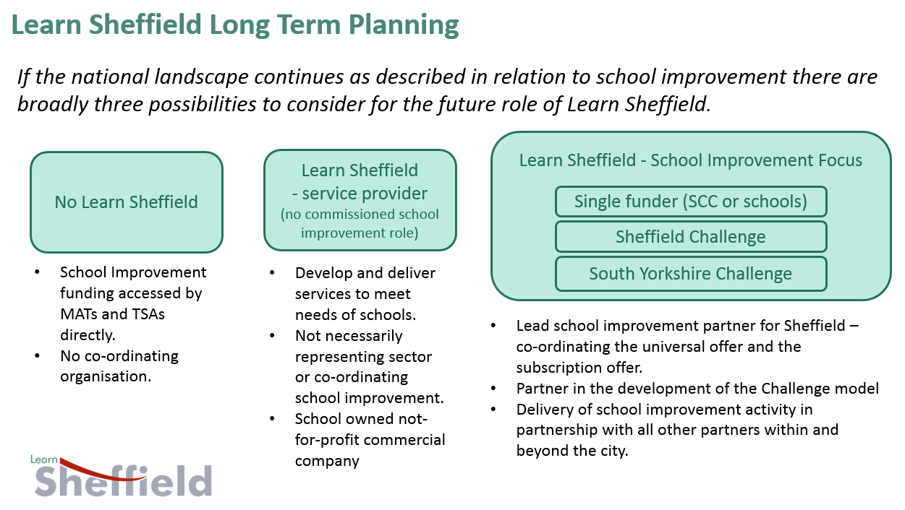
These options were set out as described in this slide in the vision and future sessions held with each school sector in the summer term. The ‘single funder’ model was included for completeness but is not considered as a realistic alternative because neither SCC or schools are likely to be in a position to fund an enhanced system.

  - A fragmented education landscape with sub-optimal use of resources and no co-ordination or wider Sheffield purpose
The implications of a more fragmented system are already felt in a number of areas within education policy, with individual institutions and MATs increasingly prepared to follow strategies in relation to admissions, places, catchment areas and inclusion issues which do not take account of wider concerns. The advent of Learn Sheffield has slowed this separation process and, in some areas (for example the sharing of data and secondary school improvement), reversed it. The opportunity now is to maximise the use of resources across the system to deliver a co-ordinated strategic approach.
Conversely, if this process of fragmentation was now accelerated by the removal of a place based strategic approach then SCC would effectively be in the position of trying to influence a free market without levers, incentives or relationships. In this scenario all of the opportunities described elsewhere in this paper are effectively reversed, with the city dependent upon national policy direction to influence the drivers of the school system.
To take the skills issue as an example, current national education policy drives schools to address the accountability framework and the progress eight measure, which leaves limited scope to focus on anything which doesn’t serve this agenda (which we also want them to be successful at). Whilst there is an opportunity now to develop a greater focus on this through a partnership funding agreement which includes this within its strategic objectives, if we don’t take that opportunity it can only move forward if national government makes significant changes to raise its relevance to schools, however important it is to our local economic priorities.

  - The SCC role in education becomes extremely limited with a lack of levers to challenge variable performance, including in relation to pupil readiness.
It seems clear that current national policy is comfortable with the principle that the local authority role in education should be limited, despite political ambitions for education and skills. It is less clear that this can work, hence the possibilities of a modification to this policy, or that this is what communities and those who serve them want to happen.
The changes that have happened so far have been hard to understand and accept for both Councillors and those they represent, but if we are unable to reach a position where a partnership funding approach can support a place based education strategy then the education landscape that will follow will be considerably more distant from local democratic accountability.
It is unlikely to include a significant role for SCC, even if the government leaves a number of statutory duties with the LA which relate to schools, because the school system will no longer see local authorities as relevant to their core business. School improvement and accountability measures will always drive the behaviour of schools and this means that any partner who doesn’t have an impact on this will always be marginal in their thinking. Conversely, SCC in the role of commissioner and strategic funding partner to the education sector can connect Learn Sheffield to economic and health priorities in a way that will be perceived as relevant by the school sector.

  - This opportunity won’t come around again in the foreseeable future
Leading local education policy in the past two years has felt, for the most part, like swimming away from a waterfall against an often strong current. Across the school improvement agenda we are trying to overcomes the deficits in flawed national policy making, to implement a place based strategy using instruments that were often designed to replace place based approaches. Our success in doing this, with limited resources, has created a platform for a more ambitious strategy but this opportunity will not be there for long as the uncertainty about national education policy is replaced by less fluid structures.
The fluidity of the educational landscape is matched by the uncertainty of regional political and economic arrangements. The opportunity of linking our ambition for education more explicitly into the various agendas relating to the regeneration of the North of England is presumably also time limited.
In terms of timing, the end of the current commission is the reason that we are discussing this now but, for all the challenges outlined in the previous section, there are a number of factors that make this an opportune moment to act.

- The Timeline – When does this need to happen?

5.1 We need a clear future direction by December 2017 at the latest.
The timeline below outlines the key activity that is required in each term of this school year in order to begin to deliver the strategy from September 2018. Service transfer has not been included in this timeline, as it is a separate piece of work, but it must also be born in mind as it remains a crucial part of organisation growth and credibility.

If a clear direction is not in place by December then this does not provide schools with the information they need, for both school improvement and budget planning purposes, and the time to make decisions and have them agreed by their governors or trustees. The spring term is the least time required to achieve this and it would be beneficial if this process could begin earlier. Once school engagement has been secured the key processes, including budgets and recruitments, can be confirmed and the key strategy documents below can be finalised and shared.
Key Documents:
- Sheffield Priorities Update – this will provide an update on the 2017/18 work and clarify the refinements to the objectives and set out the key strategies for 2018 onwards.
- School Improvement Strategy (2018-23) – this will set out the ‘Sheffield Challenge’ in greater detail and be informed by inputs from a range of external partners (including HMI and the RSC).
- 2018/19 Development Programme – this will map out the programme for the first year of the new strategy, building on the approach taken this year. It serves to both explain and publicise the opportunities that exist for schools to engage with key strategies.
Learn Sheffield has scheduled a peer review, which will be led by Christine Gilbert (formerly Head of Ofsted), for the autumn term and moved back the AGM to the start of February. This timing can be used to support both the securing of school engagement and community support for this strategy (see also appendix three). If this strategic approach is not happening then this allows Learn Sheffield a short period in the new year to prepare alternative future plans, including winding up, (see 4.1) to present to the AGM.

- The Model – How does the model work?

  - Core funding (from schools, Learn Sheffield and SCC) underpins the strategy.
Each of the proposals (appendix 1 and 2) contains a funding model with contributions from the school sector, Learn Sheffield and SCC to provide an amount of core funding for the strategy. The school contribution would be realised through a subscription as described below. The contribution of Learn Sheffield comes from surplus generated from activities being re-invested in the strategy. The commitment of SCC to one of these models will provide the platform to secure these contributions.

  - A school subscription package delivers the strategy in return for the school contribution.
The diagram below describes the delivery of the strategy and how it will be funded. The core funding underpins the system and funds the range of priority strategies that have been identified to secure educational improvement. These strategies, which in reality will be grouped and layered more than they appear in the diagram, are delivered through the school subscription package, with some providing universal content and others being targeted. Each of the proposals (appendix 1 and 2) contains a description of the likely strategies for 2018/19, the funding attached to those strategies and the school subscription offer that might arise from this.

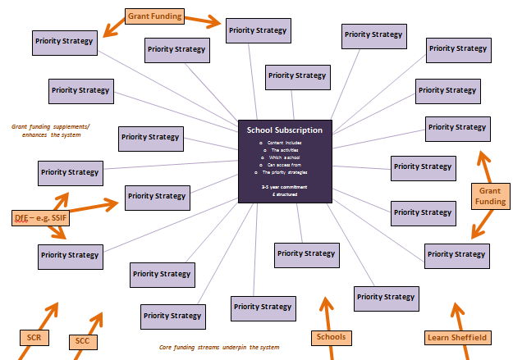

To be successful a subscription offer must be sufficiently compelling for schools, academies and MATs to make the decision to subscribe. Four key elements have been identified to secure this success.

Four key components of a subscription model …
- We want to retain the ‘Sheffield’ aspect and value Learn Sheffield.
- The subscription is value for money … “The market value of the offer is greater than the cost and I am confident that the quality is right”
- The content of the subscription includes things which enable me to off-set some of the cost ... “It replaces some things I already have in my budget or it enables me to bring in additional income that will enable me to off-set the cost”
- The school contribution levers in other funding to the system … “Our £1 creates a £4 system … we get more from this system than we could ever get from our £1”

  - Additional grant funding enhances the strategy and provides offset for the core funders.
Additional funding streams would be expected to be realised throughout the five years of the strategy. These would come from a variety of sources and be of varying amounts and scale.
These funding streams would sometimes enhance the strategy by providing additional funding that raised the overall value. This would be likely to be the case for smaller or more specifically targeted activity, which may be less likely to replace existing spending commitments, or activity that is the subject of a consortium bid in which it is difficult to disentangle the spending on the Sheffield strategy.
Other funding streams will provide offset for the core funders, when planned spending can be funded from a different source and the need for core funding in the effected years to be reduced. The timing and nature of this will determine how this offset is applied, to either support a reduced payment or provide a rebate. Decisions about how this would be applied to the core funding partners will need to be made on a case by case basis, but it would be sensible to establish principles at the outset. A government grant to local authorities, for example, may simply provide offset for SCC in helping it to fund its commitment, whereas securing the grant funding of key priority strategy may be applied to both SCC and schools in proportion to their commitment at the time. It is unlikely that offset of this kind would be applied to Learn Sheffield because any material improvement to their financial position would simply lead to additional surplus, which would be reinvested in any case.

- The Proposal – What is the Proposal?
The proposals on the pages that follow are set out in the following appendices.

Appendix 1: The ‘better than national’ £1.5m Education System
Funding Model – 2018/19 Draft Funding Plan – 2018/19 Draft School Subscription
Appendix 2: The ‘top ten percent’ £4m Education System
Funding Model – 2018/19 Draft Funding Plan – 2018/19 Draft School Subscription
Appendix 3: Draft Engagement & Communications Strategy

Appendix 1: The ‘better than national’ £1.5m Education System
Appendix 1: Funding Model
This model provides a £1.5m core funded education system in which SCC and schools are equal funding partners. Two models are set out below, which vary the way that joint funding between schools and SCC is organised. In the first (model A) the balance of funding shifts across the five years, which has the advantage of phased reduction in SCC contributions to arrive a lower figure in the fifth year, which may prepare the system more effectively for the period beyond 2023 and the potential for a self-sustaining system. The second retains an equal distribution of the contributions throughout the five years.
The Learn Sheffield contribution grows across the five years, in both models, to reflect an increasing ability to generate surplus for re-investment. This growth has been modelled to provide an approximate increase of 2.5% per annum in the overall total amount, which is designed to ensure that the value of the system is maintained in real terms throughout the five years.

‘£1.5m Education System’ – Model A
Year | School  Contribution | SCC  Contribution | Learn Sheffield Contribution | Total
1 (2018/19) | £450k | £900k | £150k | £1 500 000
2 (2019/20) | £565k | £785k | £187.5k | £1 537 500
3 (2020/21) | £675k | £675k | £225k | £1 575 000
4 (2021/22) | £785k | £565k | £265k | £1 615 000
5 (2022/23) | £900k | £450k | £305k | £1 655 000
Total | £3375k | £3375k | £1132.5 | £7 882 500

‘£1.5m Education System’ – Model B
Year | School  Contribution | SCC  Contribution | Learn Sheffield Contribution | Total
1 (2018/19) | £675k | £675k | £150k | £1 500 000
2 (2019/20) | £675k | £675k | £187.5k | £1 537 500
3 (2020/21) | £675k | £675k | £225k | £1 575 000
4 (2021/22) | £675k | £675k | £265k | £1 615 000
5 (2022/23) | £675k | £675k | £305k | £1 655 000
Total | £3375k | £3375k | £1132.5 | £7 882 500

In model A, the approximate subscription for a 300 pupil primary school would rise from £2200 to £4750 over the five years. In model B they would contribute approximately £3800 per year.
In model A, the approximate subscription for a 1000 pupil secondary school would rise from £5500 to £10000 over the five years. In model B they would contribute approximately £8000 per year.
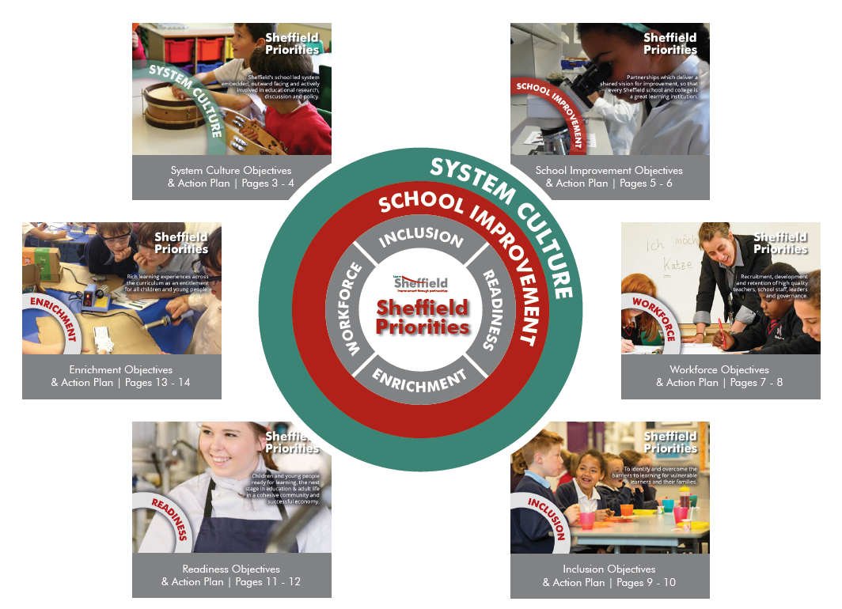
Appendix 1: 2018/19 Draft Funding Plan
Strategy Overview
This is an initial overview of a 2018/19 strategy with a £1.5m level of funding. A more detailed breakdown of both the anchor projects and the development programmes would be developed next, and this would be linked to the further development of the school subscription offer below.

System Culture
Anchor Project – Sheffield Challenge
Development Programmes – Research Led Sheffield / Communication Strategy / Projects & Compliance / Association of Education Partnerships / Fellowship

£65k (Sheffield Challenge – see School Improvement)
School Improvement
Anchor Project – Sheffield Challenge
Development Programmes – School Improvement Strategy / Achievement Strategy

£1035k (includes core team & partnership funding)

Workforce
Anchor Project – Leadership Challenge
Development Programmes – Subject Networks / Governance training / Teach Sheffield (PFA) / CPD Portal / Wellbeing & Development Advisory Group / Teacher Development / TA & Learning support development

£155k

Enrichment
Development Programmes – S-CEP & Sheffield Resource / SACRE / Maths / Reading / Writing /Curriculum/ Priorities working group /PE / Parental support & family learning / Pupil Voice

£75k (no anchor project)

Inclusion
Development Programmes – Pupil Premium Project / Inclusion Taskforce / Young Carers / Learners without labels

£65k (no anchor project)
Readiness
Anchor Project –
Growth Mindset/Aspiration Project
Development Programmes – Healthy Minds / Attendance Strategy / Move More / Early Years / Transitions & Early Risers / Vision for CYP / Post 16 Strategy

£105k

Appendix 1: 2018/19 Draft School Subscription
The detail of a school subscription would follow from more detailed strategic plans, which more closely described the scale of a strategy and the specific details of how it would be applied to different sectors. The summary below does not differentiate between the offer to different types of schools, either in terms of sector or the nature of their governance. The final offer would be structured to address the needs of each different type of school ‘customer’.

In a £1.5m school system the following would be indicative of the contents of a universal offer:
- School Improvement Strategy
- School dashboard & locality/city overview
- Categorisation
- LSIP advocacy and advice

- Briefings
- School Leaders
- Governance

- CPD Portal

- Bulletins
- Research Led Sheffield Bulletin
- Opportunities Bulletin
- Learn Sheffield Fellowship Quarterly

In a £1.5m school system the following would be indicative of the contents of a school subscription:
- School Improvement Strategy
- Support & challenge entitlement
- Partnership funding (localities and sector action plans)
- LSIP core offer (termly visits as a minimum)
- Bespoke data analysis and training

- School Improvement Services – core credit to use (e.g. performance management, staff training, review activity, etc.)

- Leadership Strategy
- System Leader Development Programme
- Moving to Outstanding programme
- School Leaders mentorship and coaching programmes
- Growing Future Leaders programme
- Next Steps Assessment Centre
- Subject Networks
- Conference package

- Governance Training Package

- Sheffield priority anchor projects – tailored to school capacity, stage of development and needs analysis. All schools will have cost free access to anchor projects built into their improvement plan.

- Sheffield priority development programmes – tailored to school capacity, stage of development and needs analysis. All schools will have cost free access to development programmes built into their improvement plan.

- Teacher wellbeing and development package – resources and programmes developed by the advisory group in 2017/18 and delivered through the subscription from 2018/19 onwards. Some elements may be included in the universal offer if appropriate.

- Communications support package – including promotion and marketing consultancy, crisis communications support, website and social media consultancy.

- Compliance Package – website compliance, bank of core policy templates, etc.

- Project support – including bid writing support, project planning consultancy and change management advice and guidance.

Additional traded services will be available to supplement the above. Some services, once they have been established at Learn Sheffield, may add to the universal or subscription offer as part of their business model.
Appendix 2: The ‘top ten percent’ £4m Education System
Appendix 2: Funding Model
This model provides a £4m core funded education system in which the balance of funding shifts across the five years to reach an equal contribution by the fifth year. Across the five years there is a 2:1 ratio of contribution between SCC and the school sector.
The school contribution level starts at the level of the even-split contribution in the £1.5m system and rises quickly. In this model the approximate subscription for a 300 pupil primary school would rise from £3800 to £9500 over the five years. In the model the approximate subscription for a 1000 pupil secondary school would rise from £8000 to £20000 over the five years.
The SCC contribution starts at just over £3m and falls over the five years to just under £2m by the final year. The proportion of the overall model being funded/under-written by SCC falls during the five years from 79% in the first year to 44% by the final year. As the balance of funding is weighted towards SCC throughout the model, only becoming equal in the final year, it would be reasonable to suggest that offset income generated should be applied to their contribution.
The Learn Sheffield contribution grows across the five years, to reflect an increasing ability to generate surplus for re-investment, but this increases at double the rate of the lower model because the additional activity in this more ambitious model will generate more opportunities to generate additional income. This growth has been modelled to provide an approximate increase of 2.5% per annum in the overall total amount, which is designed to ensure that the value of the system is maintained in real terms throughout the five years.

‘£1.5m Education System’ – Model A
Year | School  Contribution | SCC  Contribution | Learn Sheffield Contribution | Total
1 (2018/19) | £675k | £3175k | £150k | £4 000 000
2 (2019/20) | £962.5k | £2887.5k | £250k | £4 100 000
3 (2020/21) | £1250k | £2600k | £350k | £4 200 000
4 (2021/22) | £1587.5k | £2262.5k | £455k | £4 305 000
5 (2022/23) | £1925k | £1925k | £565k | £4 415 000
Total | £6400k | £12850k | £1770k | £21 020 000

This model could be viewed as a short term investment to accelerate the progress of educational performance, at a time when the potential impact could be disproportionately high, through additional funding that is not sustainable. If we are able to realise an amount of funding that is significant, but less than that which is outlined above it may be sensible to design (and tie partners in to) a system which is sustainable but structure the additional funding differently.

Appendix 2: 2018/19 Draft Funding Plan
Strategy Overview
This is an initial overview of a 2018/19 strategy with a £1.5m level of funding. A more detailed breakdown of both the anchor projects and the development programmes would be developed next, and this would be linked to the further development of the school subscription offer below.

System Culture
Anchor Project – Sheffield Challenge
Development Programmes – Research Led Sheffield / Communication Strategy / Projects & Compliance / Association of Education Partnerships / Fellowship

£240k (Sheffield Challenge – see School Improvement)
School Improvement
Anchor Project – Sheffield Challenge
Development Programmes – School Improvement Strategy / Achievement Strategy

£1565k (includes core team & partnership funding)
Enrichment
Anchor Project – Curriculum Developments
Development Programmes – S-CEP & Sheffield Resource / SACRE / Maths / Reading / Writing /Curriculum/ Priorities working group /PE / Parental support & family learning / Pupil Voice

£410k (no anchor project)
Readiness
Anchor Project – Growth Mindset/Aspiration Project
Development Programmes – Healthy Minds / Attendance Strategy / Move More / Early Years / Transitions & Early Risers / Vision for CYP / Post 16 Strategy

£555k
Workforce
Anchor Projects – Leadership & Workforce Challenges
Development Programmes – Subject Networks / Governance training / Teach Sheffield (PFA) / CPD Portal / Wellbeing & Development Advisory Group / Teacher Development / TA & Learning support development

£675k
Inclusion
Anchor Projects – Vulnerable Learners Advocacy
Development Programmes – Pupil Premium Project / Inclusion Taskforce / Young Carers / Learners without labels
£545k
Appendix 2: 2018/19 Draft School Subscription
As described in appendix one, the detail of a school subscription would follow from more detailed strategic plans, which more closely described the scale of a strategy and the specific details of how it would be applied to different sectors. The final offer would be structured to address the needs of each different type of school ‘customer’.
The basis of the universal and subscription offer would be as described in appendix one, with the additional strategies reflected in significantly greater levels of content. In a £4m school system the key differences, which generate this additional content, are outlined below.

Appendix 3: Draft Engagement & Communications Strategy
The diagram below provides an overview of the strategy for engaging the education sector and developing a successful communication strategy. In all instances the earlier a decision is made the better this works, with December 2017 the point at which a later decision makes it difficult to deliver from September 2018 (see section 5).

November
– Learn Sheffield Peer Review & Leaders Briefing

February
– Learn Sheffield AGM

June
- Leaders Briefing / soft launch

