The ‘new’ service offer from Educational Psychology
From September 2016 the Sheffield Educational Psychology Service has been centrally funded. Previously it was a traded service. This change was made to ensure that Psychologists were available to all schools and that they could play an active role in promoting early intervention support and locality working.

Working through consultation:
All schools have a named EP. However, The EP service now operates largely through consultations:
- School are offered drop-in consultations where class teachers and parent/carers get the chance to talk through concerns and plan practical actions to move situations on.
- Group consultation are offered for the SENCOs in each family of school to work together to devise creative support plans for children and young people (CYP) with more complex needs.
The idea of using consultations is linked to a conviction that conversations and practical help is more useful and effective than simply report writing (although reports, at times, obviously have their place). There is agreement that evidence of active EP involvement in the Assess, Plan, Do, Review cycle, shown in review notes, can indicate EP involvement just as well as a written report from an EP. Alternative recording methods are also being explored which promote person centred planning.
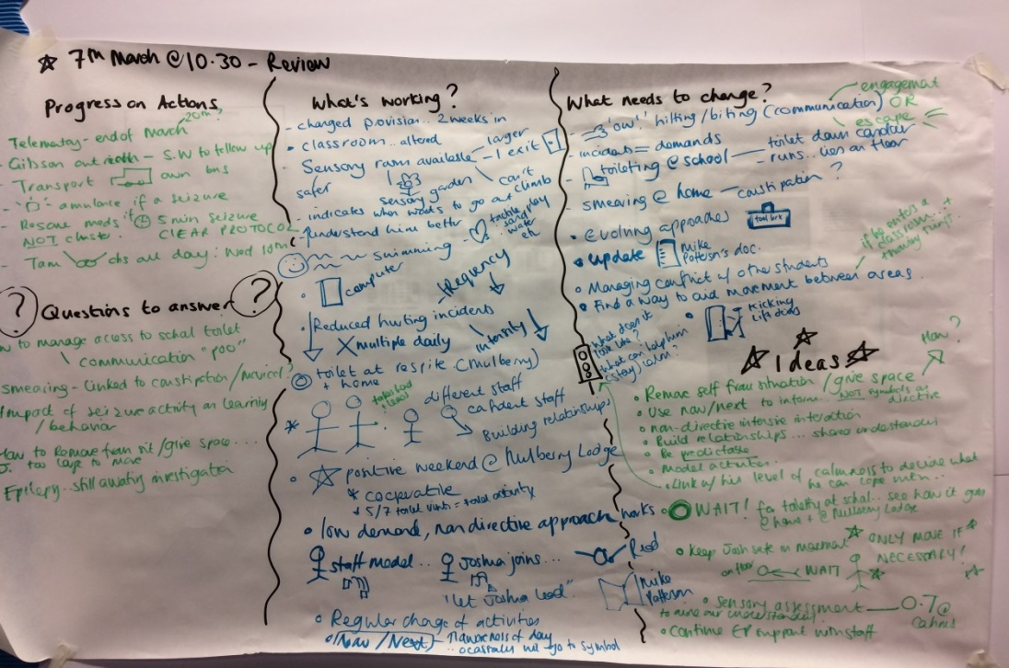
Initial evaluations suggest consultations have been viewed positively. Impact measure have been developed which after one term will provide feedback on whether the conversations have led to positive changes for CYP, families and teachers

Our three new Assistant Psychologists have been busy supporting this new ‘active’ approach; leading intervention groups in schools, developing training materials, conducting focussed observations and supporting research projects.

Support for the most vulnerable:
We continue to provide statutory psychological advice for the local authority. In addition EPs have completed planning meetings with schools to get an idea of those ‘vulnerable’ CYP who might require EP input. For some this might be reviews of their EHC plans. For others it may be supporting schools in meeting the needs of child looked after or those at risk of exclusion. It is intended that closer links with the early help provided by MAST will ensure that we develop more integrated services.

Locality working:
All localities have their own small team of EPs who work in their area. This team is part of the local inclusion workforce which is responsible for helping schools to identify and meet needs. Examples of current practice have included:
- Supporting schools in the moderation of Sheffield Support Grid decisions
- Contributing to locality SENCo forums in the majority of localities
- Participating in agree to assess decisions in locality D
- Devising a programme of activities linked to locality C’s wish to develop a network of leads for autism in each school. This involved focus groups to identify training needs and offering training alongside autism team colleagues.
- Providing Lego therapy training in localities B and C.
- Setting up and evaluating the ‘Friends’ intervention, which promotes wellbeing and emotional regulation, in several localities.

Autism and Social Emotional and Mental Health:
We continue to be busy supporting schools to find alternatives to exclusions. Our senior lead for Social Emotional and Mental Health has worked to develop and evaluate the Bumble Bee intervention offered by the Sheffield Inclusion Centre. This has demonstrated the relevance and effectiveness of nurture based approaches.
We intend to identify a mental health lead EP in each locality. This role will link with the development of the Healthy Minds programme which aims to provide better mental health support to schools.

Autism has emerged as a strategic focus in several localities as noted above. Our senior lead for Autism has been busy developing the use of Autism Education Trust materials across the city.

